Software Change Notice

Purpose
To fix the side effect of V007_2.

New File Version
V007_3
Changing Item and Mechanism
The following pictures, Fig1 & Fig2, show the changing points for this issue.
Fig1: Left side is new file/Right Side is old file
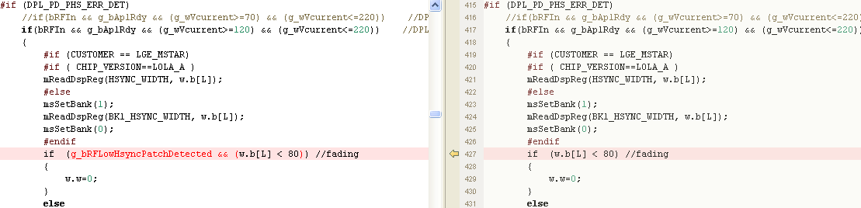
Fig2: Left side is new file/Right Side is old file
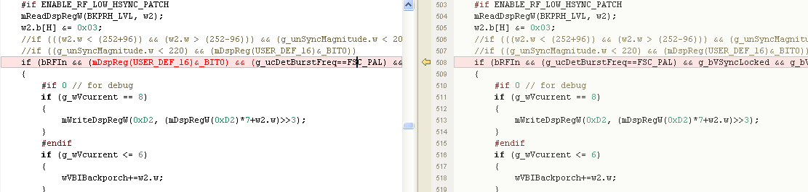

Explanation of Change
V007_2 adds hsync width detection in pll phase error calculation to improve false detection caused by broken hsync in fading channel. The detection also reduces the sensitivity for Brazil field stream. Therefore the signal can’t be detected normally as V007_1. V007_3 limits the modification for Indonesia issue only.

Evaluation Result of New Code
In all signal streams related to the modified function, side effect only happens in Brazil stream file for V007_2. We tested all related signal stream files for V007_3, it’s ok.

Owner : BY.Tsai
Reviewed by Book.Weng
Contact Window : BY.Tsai

Customer Approval

(Customer Name) agree to accept (File Version) as the official version as of (Date)

_______________________ (Name)
(Title)
(Company)

